What to do if you are worried Speak to any member of staff
This is our Safeguarding Team
Speak to us – we’re here to listen to you
Mrs Garrick
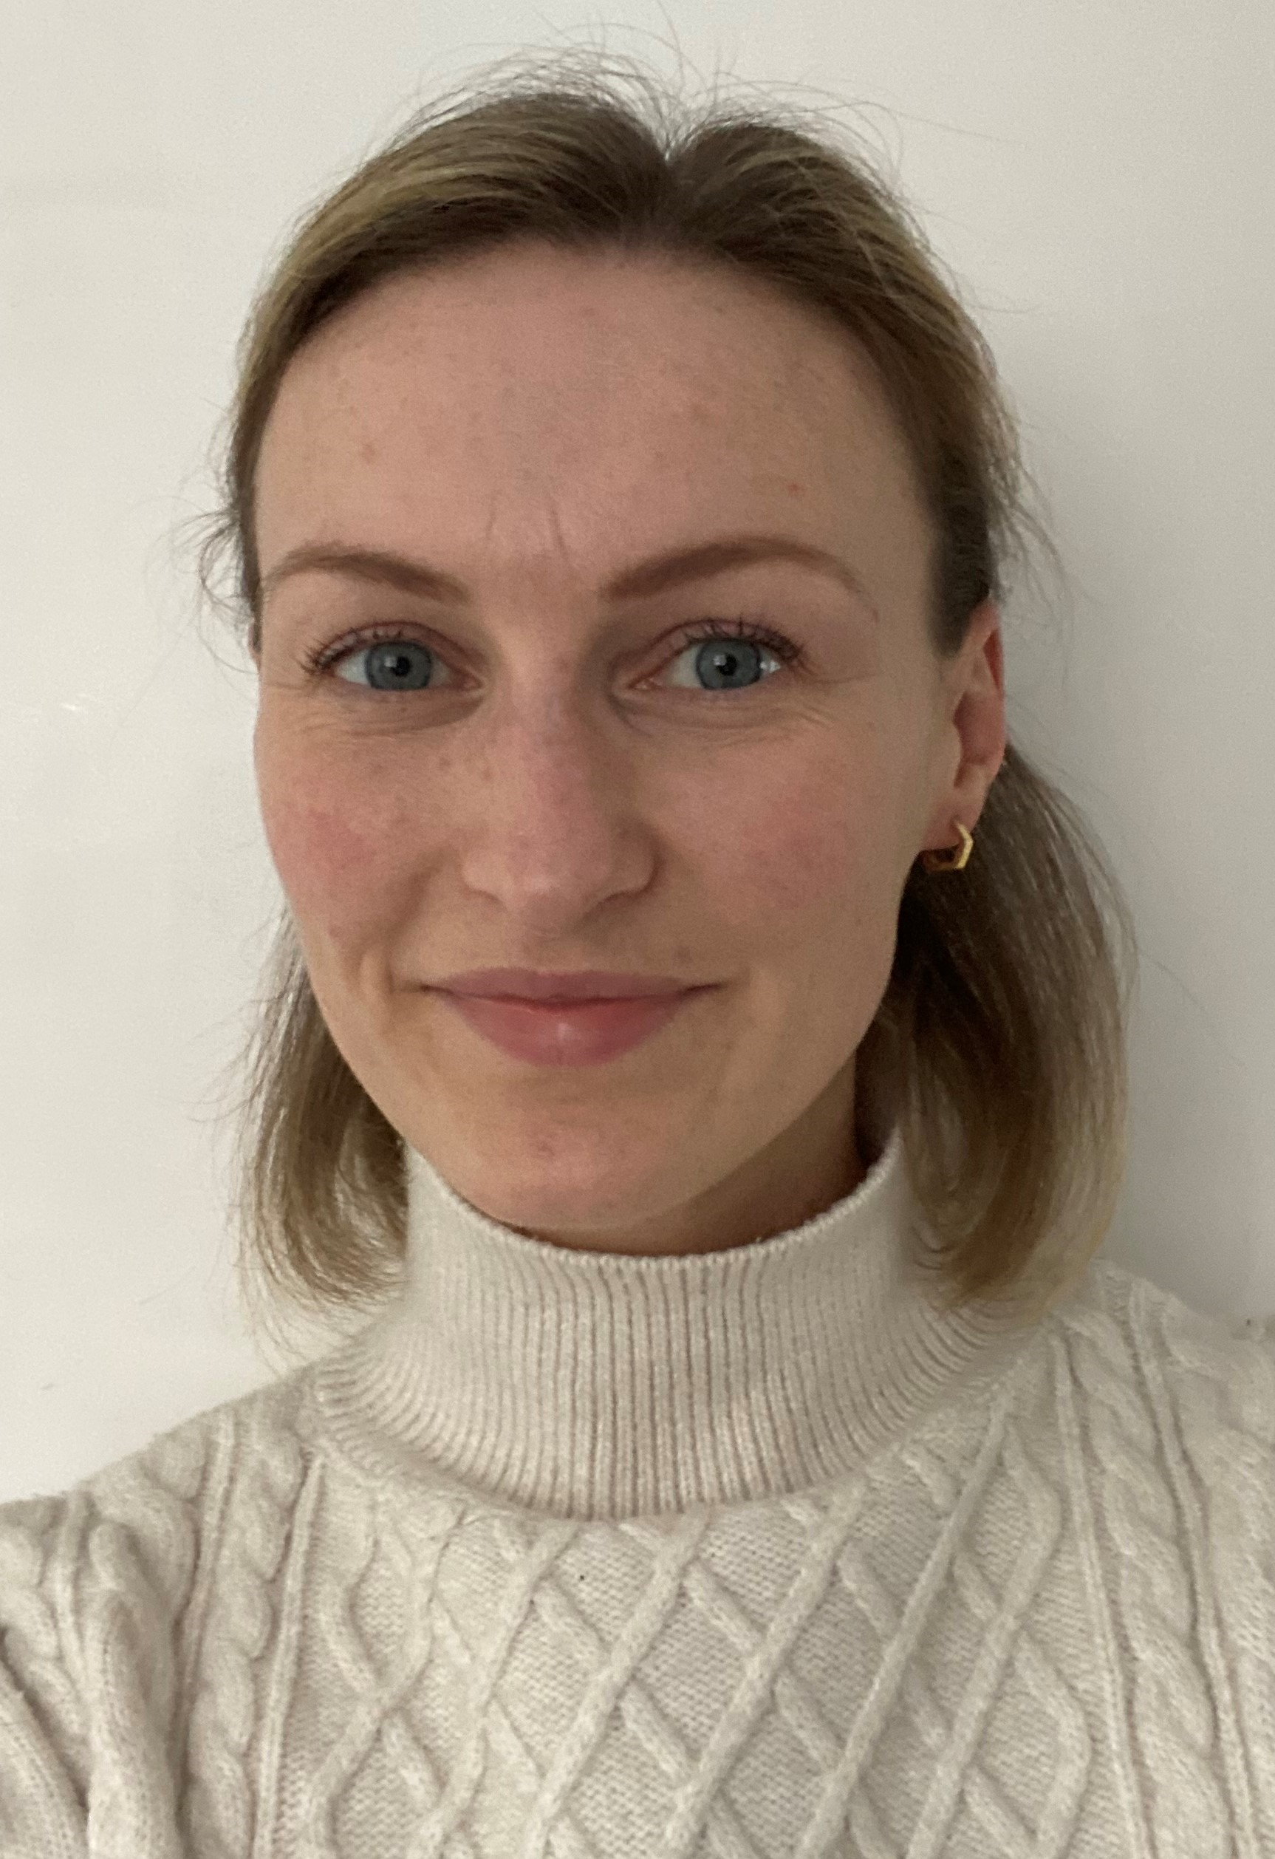
Mrs Kent
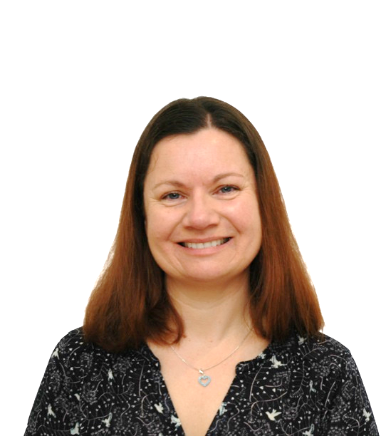
Ms Heavens
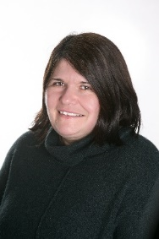
Any adult can help
Mrs Athersuch
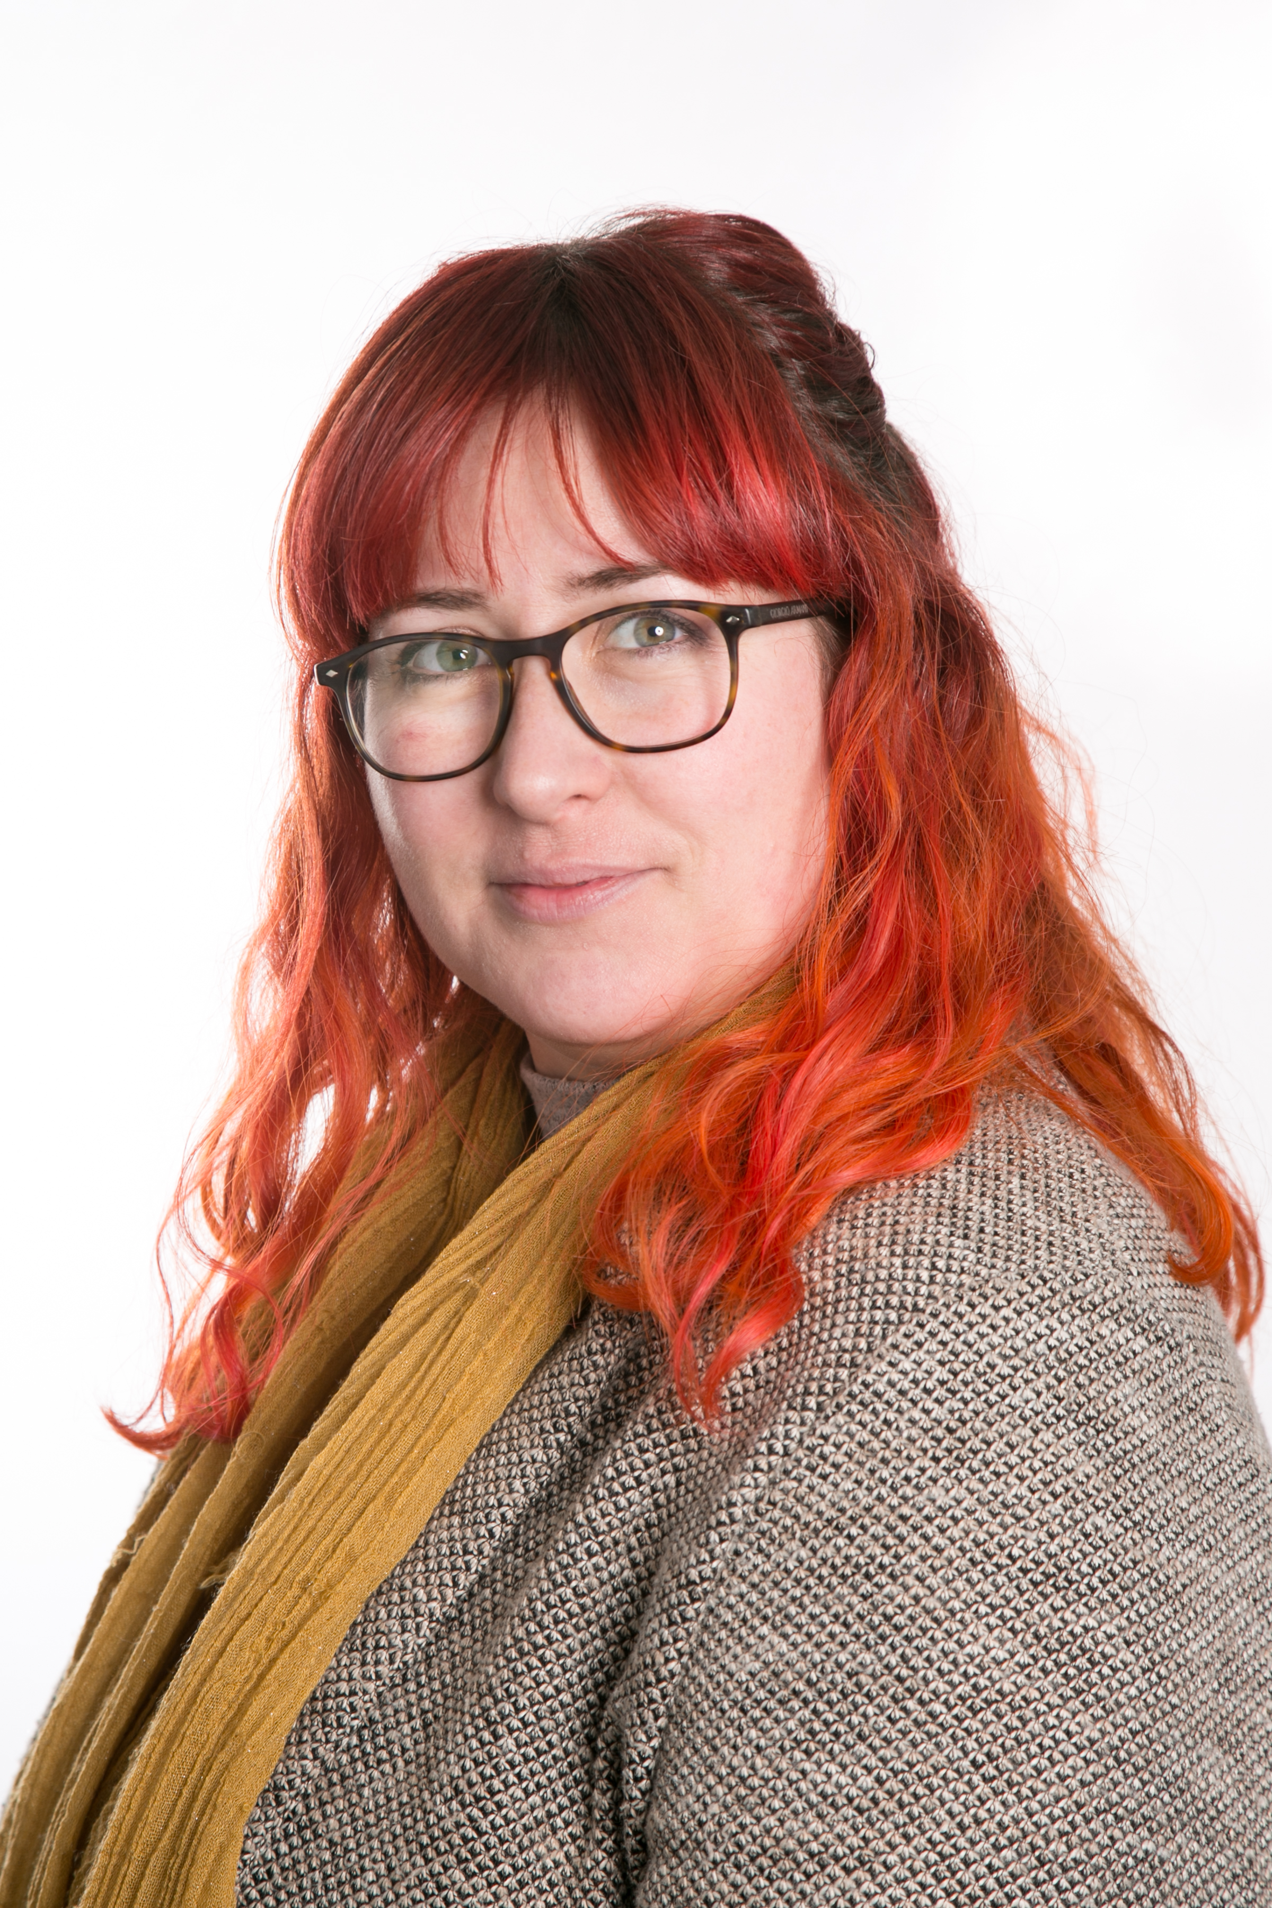
Outside of school, Childline is here for you whenever you need to talk
Need someone to talk to?
Need help?
We’re always here for you …
Miss Clifford
Mrs Ratcliff
